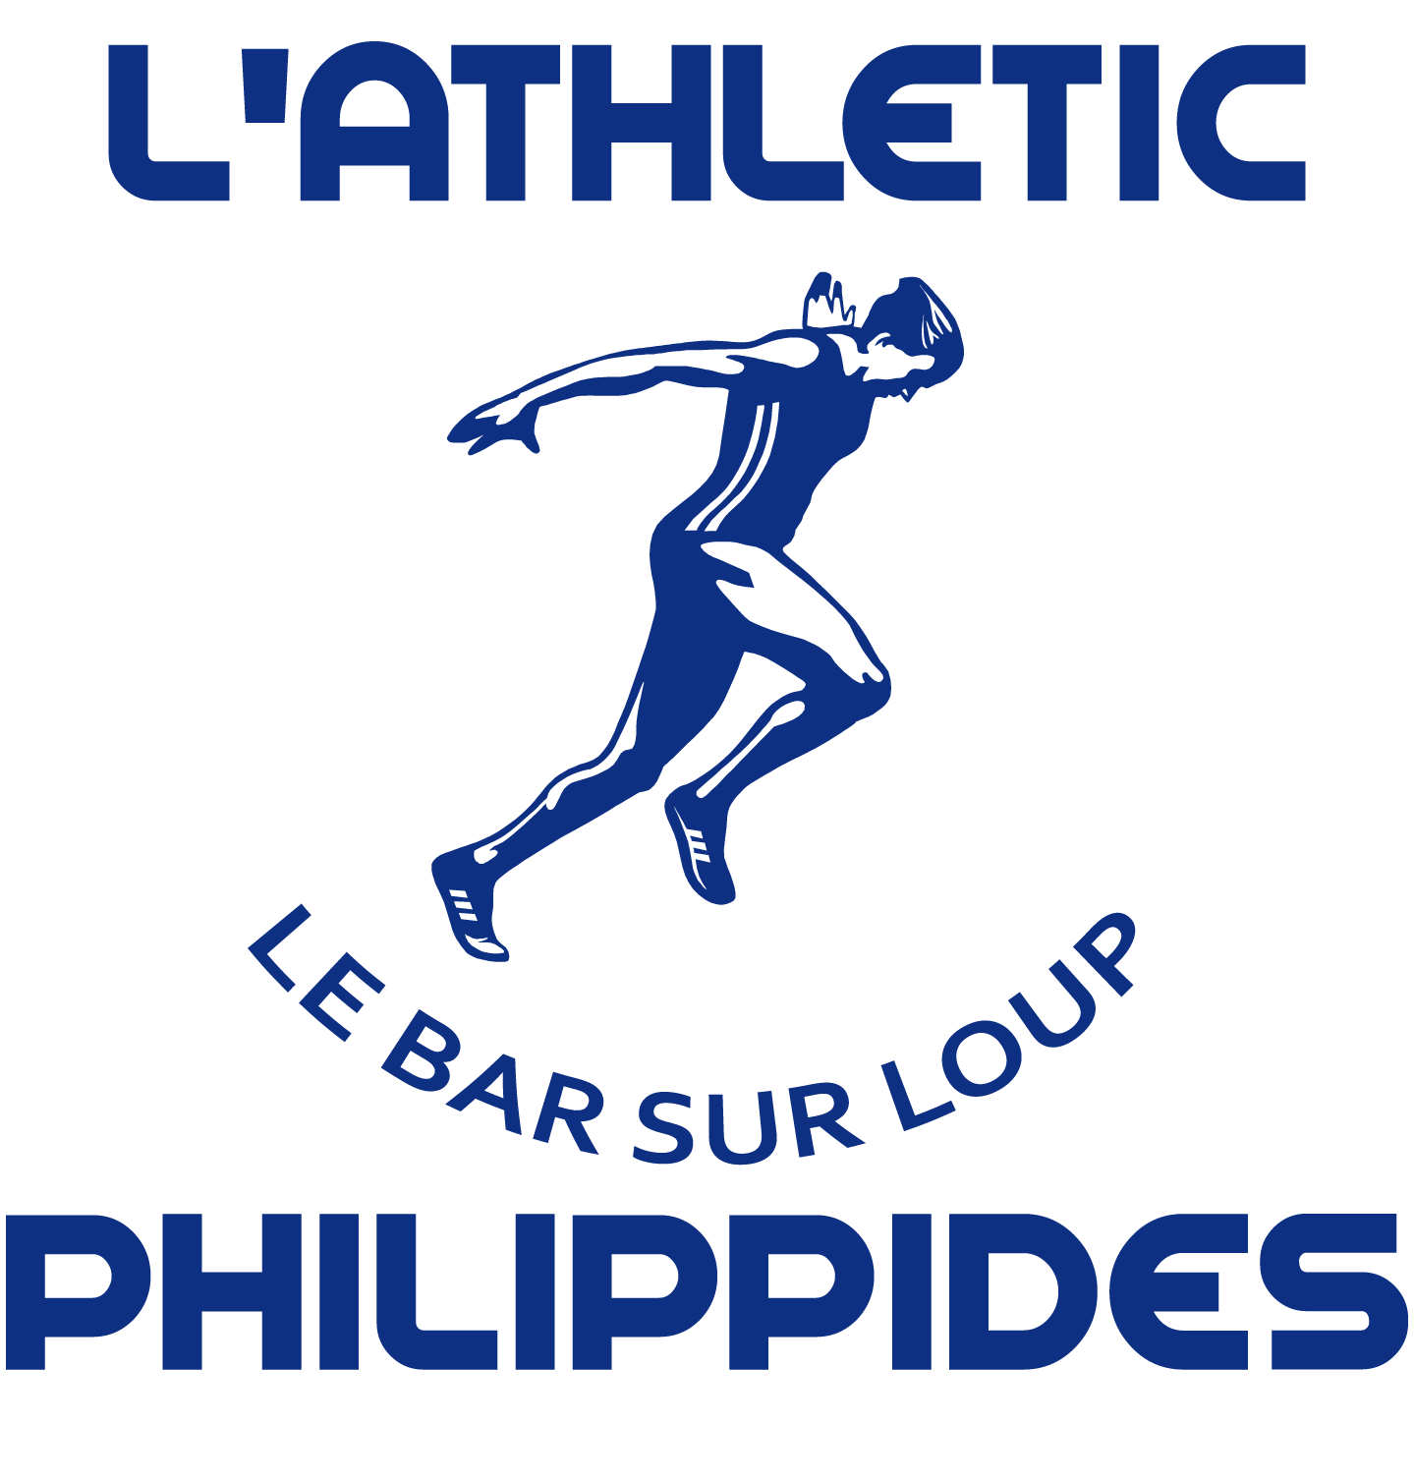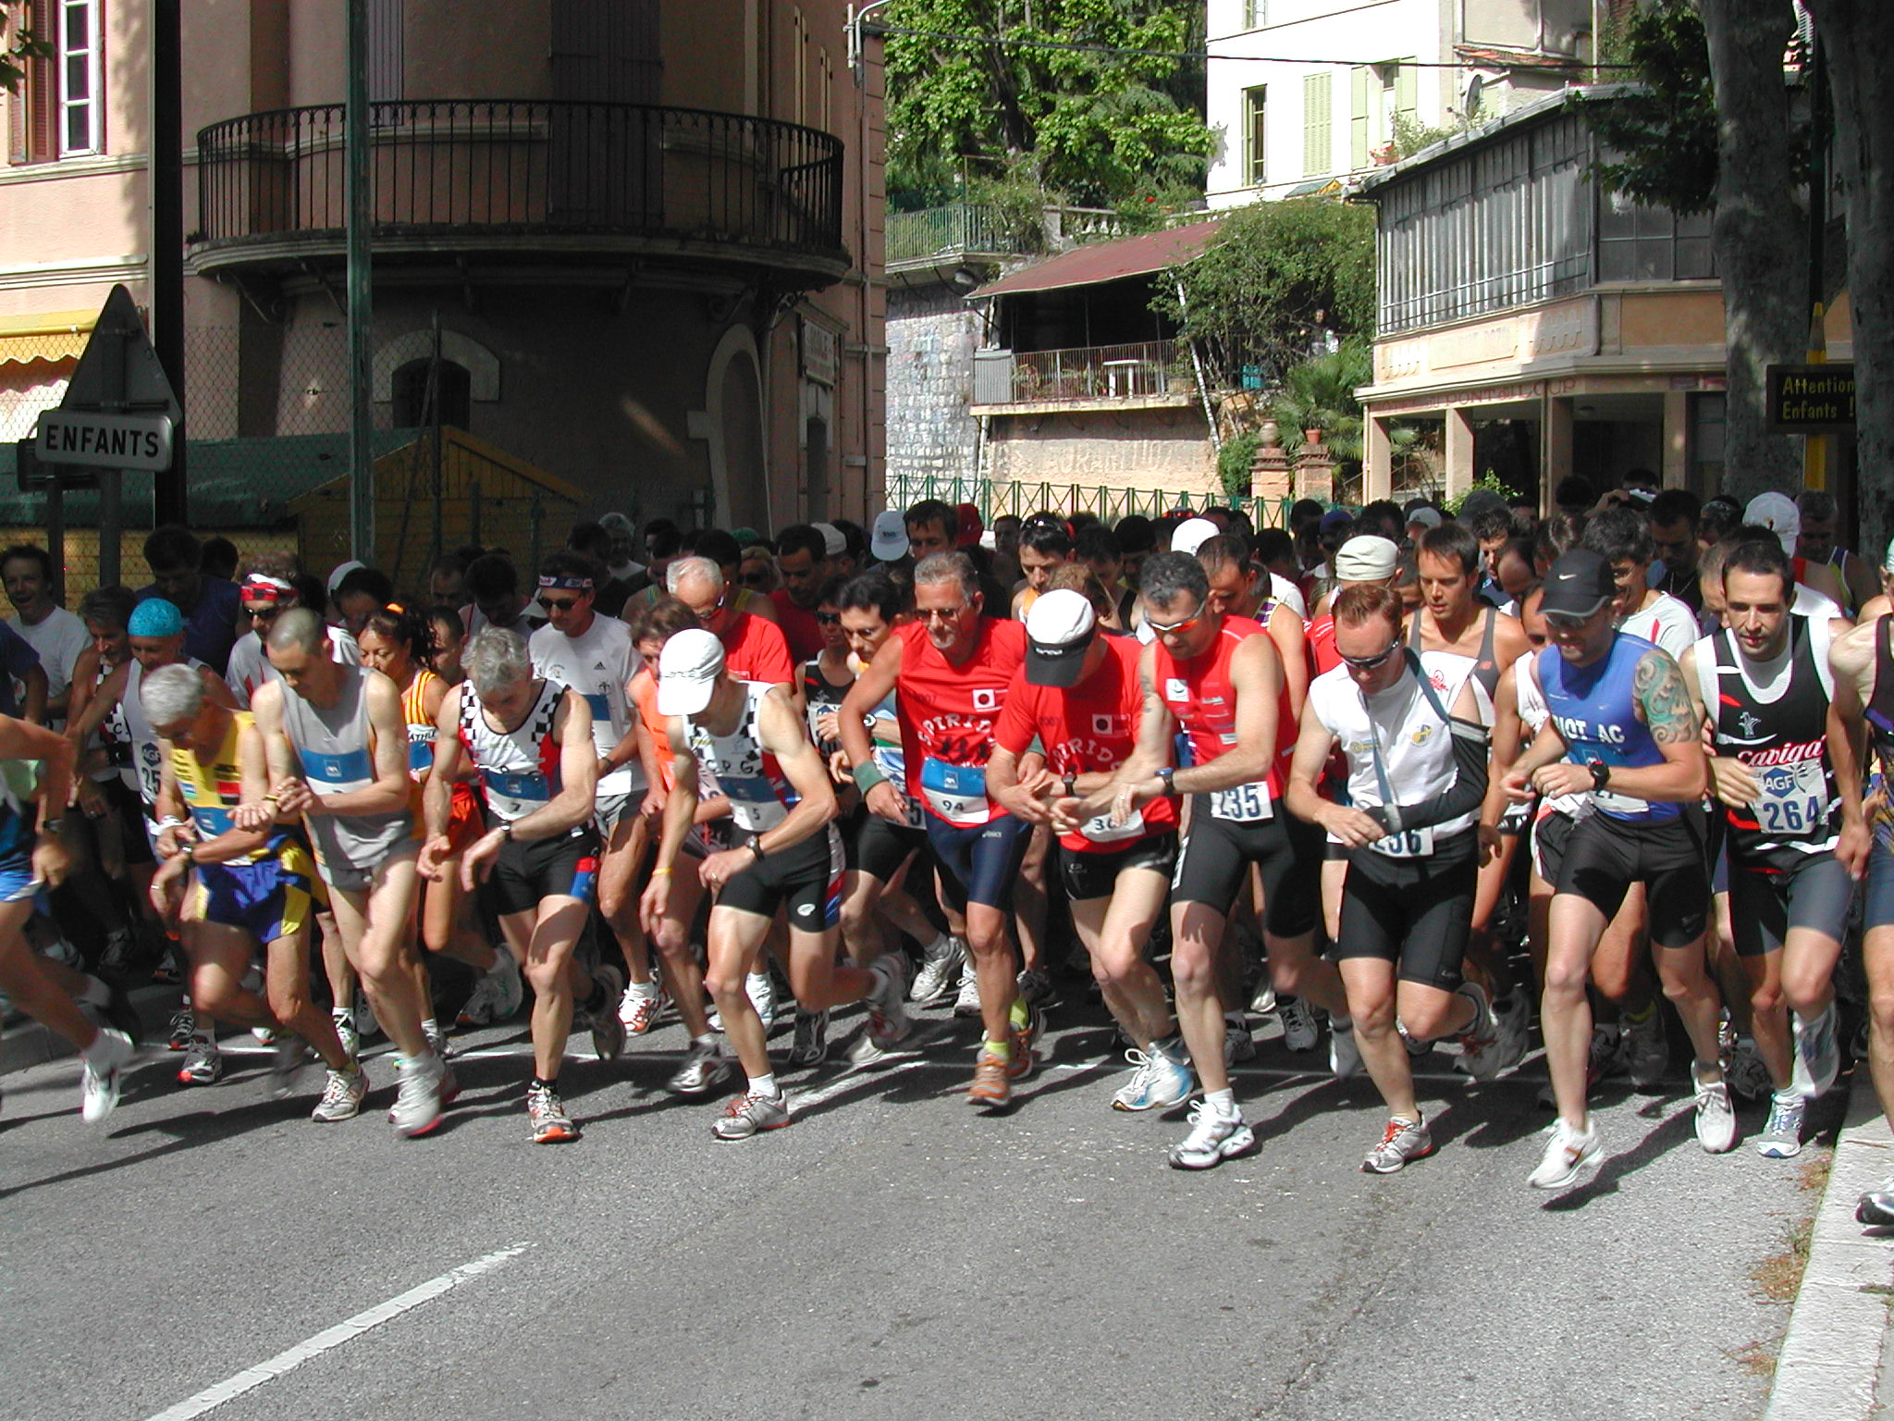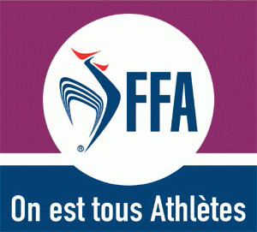

Friends, runners and beginners,

After a year of success, in an ambience of friendliness!
At the heart of our Club F.F.A with the practice of the outside course and the Nordic walking
Together, experienced runners or beginners come to uncover our beautiful “Natural Stadium”, our region with the passion of the course on foot!

For more information ,contact the leaders
SEASON 2017-2018

Return the bulletin adjoined to us:

Inscription form for 2017/2018:
Surname………………………………………………………………………………………………………………
Forename …………………………………………………………………………………………………………….
Dob……………………………………… ……………………………………………………………………………
Nationality ……………………………………………………………………………………………………………
Gender F M
Address…………………………………………………………………………………………………
Tel ……………………………………………………………………………………………………
e-mail………………………………………………………………………………………
Licence : 2 options to choose from :cheque made payable to Athlétic Philippidès C.B.L (Club le Bar sur Loup)
Athle. Health and leisure running : Club+FFA = 60€ Cadet Junior- Hope- Senior- Veteran 1/5
Athlete Competition : Club+FFA = 120€ Cadet- Junior- Hope- Senior
Athlete Competition : Club+FFA 120€ Veteran V1 / V5

Size XXL XL L M S XS
Short 44 42 40 38 36 34
Attach a medical certifcate (aptitude de non contre indication à la pratique de la course à pied en compétition)
Prescribed within 3 month of the inscription

Send to :
L’ Athlétic Philippidès Club Le Bar Sur Loup
967 Ch du Bosquet, 06620 Le Bar Sur Loup
Net : www.athleticphilippides.com

e-mail : (For information)

Antoine Cau fabienne.lacombe@free.fr Tél. 06 28 23 77 04
Marc Chatron Colliet marc.chatron-colliet@orange.fr Tél. 06 07 17 87 39
Thierry Alemany Tél. 06 17 38 91 02

